TASK 12, 1.8 pages – 3 pages, (4 paragraphs total) DUE 10/26 10PM EST

Assignment Instructions/ Information:
For this assignment, you will compose a critical response. Future leaders will have to contend with an increased surge of fake news, misinformation, disinformation, and conspiracy theories. You are a future leader and must express your reaction to the ideas presented in these arguments. As you compose your response, think about the future of leadership. Reread textbook Ch. 2, p. 82 (attached below). Writing a Critical Response. Compose a three-paragraph critical response to the essay on p.427 (attached below).

Then, in the 4th paragraph, you will reflect on your thinking. Consider the assignment that presented you with the most challenges. (so friend, pick one of the assignments you did before including: Task 1 (President Barack Obama's 2009 Inaugural Address and identify logical fallacies), Task 2 (Effective Apology), Task 3 (argumentative essay (synthesis essay), Task 4 (rhetorical analysis of the Ravisankar’s “Sweatshop Oppression.”), Task 6: The Case of Slip or Trip, Task 7 (The Toulmin Problem-Solution Argument))

- Given what you know now, if you could approach your assignment again, how would you do it?
- How has your understanding of the task changed? Explain.
- How will your new understanding of the assignment change your future action or thought? Explain.

p. 82
Writing a Critical Response
Sometimes you will be asked to write a critical response—a paragraph or more in which you analyze ideas presented in an argument and express your reactions to them.
Before you can respond in writing to an argument, you need to be sure that you understand the writer’s position and that you have a sense of how supporting ideas are arranged—and why. You also need to consider how convincingly the writer conveys his or her position.
If you have read the argument carefully, highlighting and annotating it according to the guidelines outlined in this chapter, you should have a good idea what the writer wants to communicate to readers as well as how successfully the argument makes its point.
Before you begin to write a critical response to an argument, you should consider the questions in the checklist.
Begin your critical response by identifying your source and its author; then, write a clear, concise summary of the writer’s position. Next, analyze the argument’s supporting points one by one, considering the strength of the evidence that is presented. Also consider whether the writer addresses all significant opposing arguments and whether those arguments are refuted convincingly. Quote, summarize, and paraphrase the writer’s key points as you go along, being careful to quote accurately and not to misrepresent the writer’s ideas or distort them by quoting out of context. (For information on summarizing, paraphrasing, quoting, and synthesizing sources, see Chapter 9.) As you write, identify arguments you find unconvincing, poorly supported, or irrelevant. At the end of your critical response, sum up your assessment of the argument in a strong concluding statement.

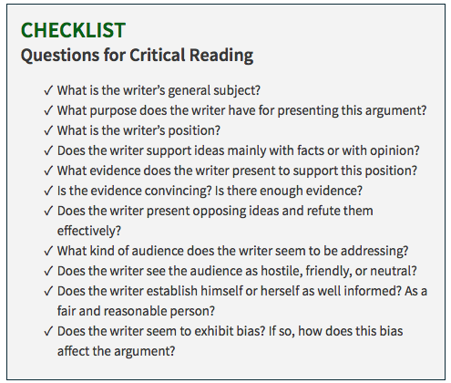

Essay p. 427
